**CW Machine Window**

# Geoff Anderson G3NPA, Hew Lines VA7HU, ~~and~~ Aki Yoshida JA1NLX and Orrin Delany WO4D

## 1.0 GENERAL

The CW Machine provides the capability to interface Logger32 to your transceiver and to send CW from Logger32 via a serial or parallel port interface. It is fully customizable and consists of a transmit buffer window and up to 36 user-programmable buttons that may be displayed in groups of  0, 12, 24 or 36. Each button may be programmed using Macro language statements and/or text and may be colored and labeled. Using your imagination and the Macro language, you can create single-button functionality which will make operating CW more enjoyable and easier.

The CW Machine is basically a software keyer but it will also support the use of a WinKey1 or 2 CW keyer.

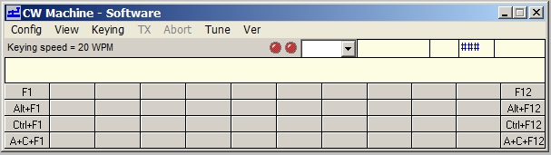

CWM_1

**Note:**

If the CW Machine is running when WSJT/JTDX is started, the CW Machine will close automatically. If, while running WSJT/JTDX, a CW DX Spot is clicked, when WSJT/JTDX is closed the CW Machine will open automatically.

If WSJT/JTDX is running and the user wishes to switch, simply click on the CW Machine ICON on the ToolBar and WSJT/JTDX will close and the CW Machine will open.

## 2.0 MAIN MENU

The CW Machine Menu Bar provides the following functionality:

### 2.1 Config

As a general note, it is recommended that after making any change to the keyer's configuration settings that the CW Machine be closed down and then re-opened. This does two things;:

* + It saves the new configuration, and
  + It allows the software to configure itself correctly to the new settings.

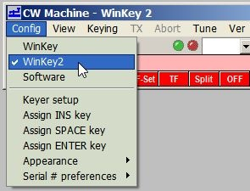

CWM_2

### 2.1.1 WinKey/Software

It is in this menu where the selection between using the built-in CW keyer and an external WinKey keyer is made.

Select "Software" for the internal keyer. The selection made here will produce different keyer setup dialog boxes as described later. "Software" is displayed in the Title bar.

Also note that the meaning of the LEDs changes between the two configurations. When using the software keyer, the LEDs are as shown in the screenshot below and depict the keying and PTT.

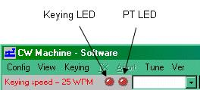

CWM_3

When the WinKey option is selected, the left LED indicates (when green) that a Host connection with WinKey is established. “WinKey” or “WinKey 2” is displayed in the title bar.

The right LED indicates the following status:

* + **Green** Sending text;
  + **Red** Idle;
  + **Blue** Sending with paddle; and,
  + **Orange** Sending a Wnkey internal message.



CWM_4A

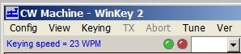

CWM_4

### 2.1.2 Keyer Setup - Software

Selecting this menu item will display the Keyer Setup dialog box, as shown below (CWM_6). From this panel the user can:

* + Set the serial port and/or parallel port address to be used;
  + Check which port is going to be active;
  + Select the PTT method;
  + Set the CW speed (faster to the right and slower to the left) in WPM;
  + Adjust the CW weighting;
  + Set the required transmit delay (the time between the PTT being activated and the start of the first symbol to be transmitted);
  + Set the "Disable radio polling when keying" option will do just as it indicates.  This feature was introduced to overcome a problem reported with Omni V rigs when being keyed;
  + Select an immediate character abort when using the <**Esc**> key (rather than allowing the character to complete) when using the software version of the keyer; and,
  + Test the actual keying speed.

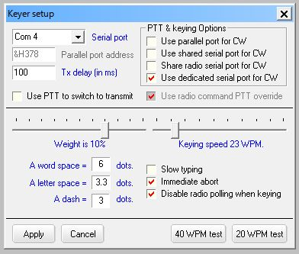

CWM_6

### 2.1.3 Using the Parallel Port

If you choose to use the parallel port for the CW Machine, all that is required is that you set the parallel port address, select the "PTT on selected port" and "Use parallel port for CW" check boxes.

### 2.1.4 Using the Serial Port

If you choose to use a serial port, you have three options:

* 1. Use a dedicated serial port for PTT control and CW keying;
  2. Key the radio using the spare control signals in the ports used by the rotator or the radio; or
  3. Switch between the radio ports used for SO2R.

**Note**: Only one of these options may be selected at any one tiome.

The serial port selection now supports USB adaptors.

### 2.1.5 Using a Dedicated Port

Select a Serial Port from the pull-down menu and then select "PTT on selected port" if required.

**Note**: Hex address only applies to parallel port selection.

### 2.1.6 Using a Shared Port

It is possible to share the CW port with either the (serial) radio port, (serial) rotor port, or (parallel) antenna port.

If sharing with the (serial) radio or rotator port, then check the "Use shared serial port for CW" option.

Sharing the radio serial port for CW is intended for SO2R users who require to use the RTS and DTR signals available in the radio comms ports and to have these switch between ports under the influence of the <**Ctrl+T**> SO2R changeover function.

If sharing with the (parallel) antenna port:

* + Set the parallel port address to match that for the antenna port; and,
  + Check the "use parallel port for CW" option.

Your attention is also directed towards the Shared Serial and Parallel Ports section.

You will observe that the address for the parallel port is a hexadecimal value and should be entered in the format "&Hxxx" and not as a description as LPT1 etc. If you do not know the address of your port, right-click on the "My Computer" icon on the desktop and select the "Properties|Device Manager" entry. Highlight the port of interest and select "Properties"

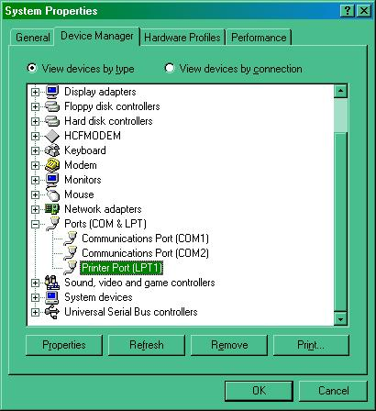

CWM_7

The "Resources" tab will give details of the Input/Output ranges.

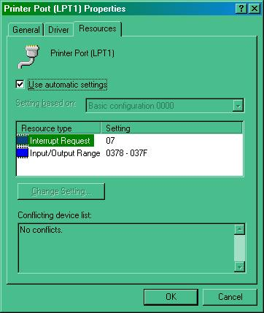

CWM_8

The address you require will be the first of these two numbers. Drop the leading zero and enter the remainder in the form &Hxxx.  On standard systems LPT1 = &H378. For other ports, check the values needed using the method described above.

The PTT delay is a built-in delay to allow for relays (or other general delays) within your system to change over before the CW text is actually sent to the transmitter. The value entered here should be in milliseconds.

How fast are you really sending?  Selecting one of the two WPM test buttons will cause the keyer to place the word "Paris" into the TX buffer either 20 or 40 times and then send it. This is a timed process to determine the actual WPM that your computer is sending. The results will be displayed in the message box below. It is recommended that you have the radio turned OFF before you try this!

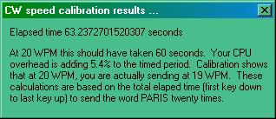

CWM_9

### 2.1.7 Slow Typing Options

From Ver. 3.1.2 of the CW Machine, the Slow Typing option has a different function. With the Slow Typing option checked, the keyer does not automatically revert to receive when the buffer is sent. The keyer can be forced to receive (PTT turned off) by clicking Abort, typing the <**Esc**> key, or executing the $receive$ macro.

**Note**: the object of the Slow Typing option is to prevent the radio PTT going on/off as slow typists pecked their way through a message.  Unless a user has a specific need for the slow typing option, it is STRONGLY RECOMMENDED THIS OPTION BE TURNED OFF.

### 2.1.8 Keyer Setup - WinKey

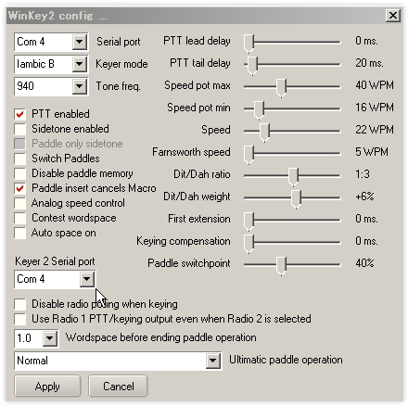

CWM_10

Added Radio 2 serial port to the CW Machine WinKey and WinKey2 setup (ver3.50). In the case of WinKey2 it supports 2 CW output for Radio1 and Radio2. You must specify same serial port. in the Keyer 2 serial port box.

Full information on all of these settings can be obtained from the WinKey Interface manual downloadable from <http://k1el.tripod.com/docs.html>. Most of these settings can simply be left alone until you know what effect they will have. There are, however, one or two where a little extra information might help.

**Analog Speed Control** - Check this item if you wish to have control of the keying speed via the external control. Unchecked and Logger32 will be able to change the keying speed using a right-click on the speed indicator.

**Key On n (where n is 3 or 5)** - The default is pin 3 for the keying. Select pin 5 if this is your preference. Note for MicroKey users: It is recommended that you use pin 3 keying. If you select pin 5 then the PTT will key instead.

**Sidetone** - You are strongly advised to read the WinKey information about the use of sidetone - for this is related to the keying pin in use at the time. MicroKeyer users do NOT need the sidetone activated here. In this case it is better to use the sidetone switch in the USB device router (CW/WinKey tab).

**Key Radio 1 from pin 3, Radio 2 from pin 5** - This provides for an automatic change of the CW keying line from pin 3 to pin 5 when the radio is changed from Radio 1 to Radio 2. See the SO2R section for more details.

**Disable Radio Polling when keying** - Some radios seem to prefer that the polling cease when transmitting. This gives the user the ability to select that option.

**Notes for users of MicroKeyer -** When Logger32 opens the WinKey serial port then Logger32 takes control over ALL of WinKey including PTT on pin 5. If you do not want PTT generation from WinKey when Logger32 is running you must uncheck the PTT checkbox in Logger32. Logger32 ALWAYS has priority. WinKey pin 5 is multifunctional. Logger32 can use this pin for the following functions:

* + None;
  + PTT;
  + Sidetone; or
  + Second CW output.

MicroKeyer allows only "None" and "PTT", but Logger32 can control all functions. Inside the MicroKeyer is a jumper called SO1R/SO2R. It's a jumper for pin 5. If it is in the SO1R position then pin 5 is used for PTT. If in the SO2R position then pin 5 is disconnected from the PTT circuits and wired to the REMOTE mini DIN 6 connector (signal will be used in SO2R extension for MicroKeyer as second CW source).

### 2.1.9 Assign Insert Key

From this menu you can assign any of the preset shortcut keys to the <**INS**> key, <**SPACE**> key or <**ENTER**> key on the keyboard.

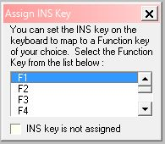

CWM_5

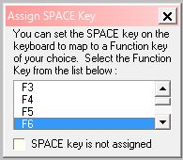

CWM_5A

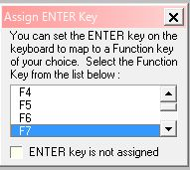

CWM_5B

### 2.1.10 Appearance

Allows for the user selection of text fonts and colors. Font settings for the text part of the window are now applied to the callsign, SRX and Name fields.

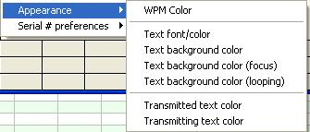

CWM-21

### 2.1.11 Serial # Preferences

This allows the user to send either a letter "T", the letter "O" or the figure 0(zero) when transmitting a zero in contest serial numbers.

### 2.2 View

* + **Show F keys**         -  Display the first row of buttons
  + **Show Alt+F keys**    -  Display the second row of buttons
  + **Show Ctrl+F keys**   - Display the third row of buttons
  + **Show Alt+Ctrl+F keys**    - Display the fourth row of buttons
  + **Always on Top**      -  Allows the user have the CW Machine always remain visible
  + **Show Controls in Microsoft 3D**  -  Displays the Visual Basic controls in 3D format
  + **Show tool bar**       -  Allows the user to display the tool bar or not
  + **Show SRX Field**   - Allows the user to display the SRX entry pane. Note: This pane normally shows '###'. To use, click the cursor into the pane and just over-type the received serial number. There is no need to backspace over the '#' symbols
  + **Show Sent RST Field** - Allows the user to display the sent RST report.

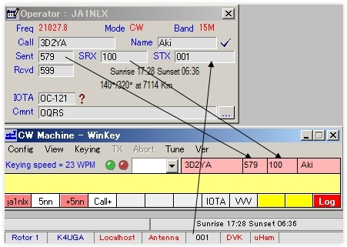

CWM_21B

* + **Debug window** - Allow the user to display communication between the CW Machine and WinKey.

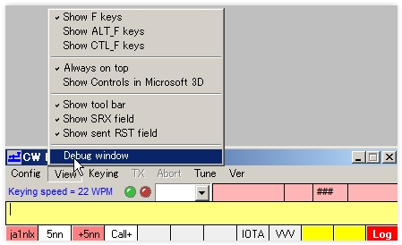

CWM_21A

### 2.3 Keying

* + **Auto TX** - With this selected, whatever is entered into the transmit buffer will be sent immediately;
  + **Manual TX** - With this selected, the contents of the transmit buffer will be sent on selecting "TX" (see below);
  + **Dedicated Serial Port** - With this checked, keying will be applied to the port as set in the Config menu. With it unchecked, the PTT and keying LEDs will flash but the port will remain inactive. Note that this menu option will be available only If the use of a dedicated port is selected in the Config|Keyer setup menu;
  + **TX** - Transmit text (only available if Keying is set to Manual TX);
  + **Abort** - Stop transmitting immediately and clears the transmit buffer;
  + **Tune** - This allows the operator to tune up his radio. The button acts as a toggle; click once to activate, click again to de-activate; and,
  + **Ver** - Version and build number information

## 3.0 KEYING SPEED

Just below the menu bar, the CW Machine displays the current keying speed. A left-click on the text "Keying speed = nn WPM" will reduce the current timing element by 1ms, while a right-click will increase the timing element by 1ms.

**Note**: In addition the <**Pgup**> and <**PgDn**> keys have been assigned for speed up and speed down

## 4.0 CW MACHINE AND CWGET

Logger32 will now "integrate" with the CW decoding program CwGet in so far as simple mouse clicks can capture received text from CwGet and place the resultant text into the Logbook Entry window of Logger32.

CwGet is not part of the Logger32 distributed package and the user must obtain their own copy of this program. One source is <http://www.dxsoft.com/en/products/cwget/>.

NOTE: If Logger32 is required to “Run as Administrator” then CWGet will also have to be Run as Administrator” or else the programs may not work properly.

To make use of this facility, CwGet needs to be set up as follows:

~~Check the CwGet SETUP menu options "CATCH WORD BY ONE MOUSE CLICK" and "COPY TRANSFERRED DATA TO CLIPBOARD" as shown below, and then save the new setup.~~

Click “Setup” in Main menu. Most important options are in “Interface” and “Text” tab. You have to Apply and Save the changes as you make them.

In “Interface” tab select information/number for Input and Output soundcard.

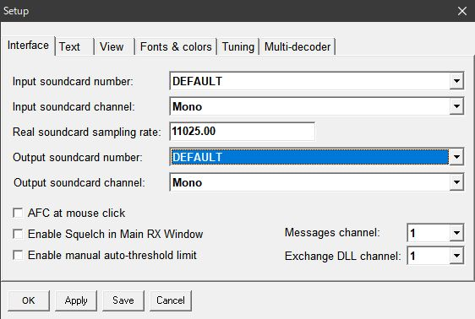

New CWM_16

In “Text” tab check items below.

Check the CwGet SETUP Text menu options check "CATCH WORD BY ONE MOUSE CLICK" and "COPY TRANSFERRED DATA TO CLIPBOARD" as shown below, and then Apply and Save the changes.

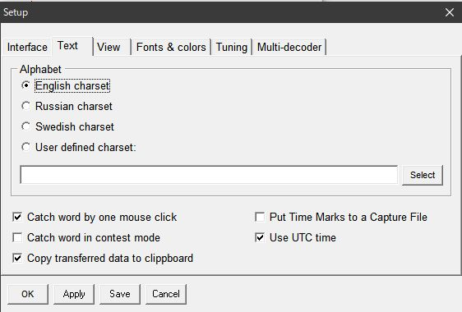

CWM_16A

To use the facility, left-click the mouse on the selected text as displayed in the CwGet decode window. A menu will then pop-up with the text selected.

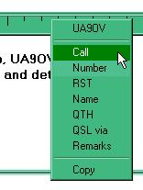

CWM_17

Clicking on one of the menu options will then transfer the text to the Logbook Entry window in Logger32 as seen below.

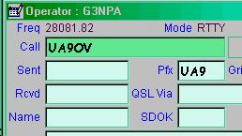

CWM_18

## 5.0 MACROS AND PROGRAMMABLE BUTTONS

### 5.1 Definitions

**Macro** - Commands provided by the programmer so the user can create limited routines or shortcuts. Macros are used when creating routines for buttons and Hot Keys.

**Button** -  Designated buttons on a dialog box that the user can customize. Labels and color can be added to the buttons to identify the routine that the button will run when selected. Each button is also assigned to a 'Hot Key'.

### 5.2 Selecting the Number of Buttons Available

Go to the CW Machine View Menu, and select one or a combination of "Show F key" options. The macro buttons will be displayed below the transmit text window, in up to four rows.

### 5.3 Programming the Macro Buttons and Hot Keys

Using the mouse, point and right-click on the button you wish to program. The Macro Setup window will appear. At the top of the window there is a description for the Macro, (example: Macro Setup for F2). That would be the second button on the first row. To program the button, click in the text window and type in the text Macro you want to send when this button is clicked.

**Note** that the storage for each button will only allow a MAXIMUM of 200 characters (including non-printing characters such as a space)

After entering the routine, enter a name for the Button Caption in its associated window at the lower right. You can also program the following features of each macro button:

* + **Backcolor** - the color of the background of the button;
  + **Forecolor** - the color of the letters of the caption;
  + **Mouseover Back**color - the color to which the background changes when you drag the cursor over it; and,
  + **Mouseover Fore color** - the color to which the letters change when you drag the cursor over it.

If you make a mistake, highlight the text and use the <**Delete**> key to erase. When the Macro Setup is complete, and you are ready to save it, press the OK button. Pressing <**Cancel**> will cause the window to close without saving your work. You can also restore the default colors.

When you have finished programming the required text and Macro commands, and selected your desired button colors, select the <**OK**> button to save the script for that button. Cancel will erase your work.  Reset/Cancel all settings will restore the Macro button to the way it was before you began editing.  If it had a script, that script will be restored; if it was blank, it will return to blank.

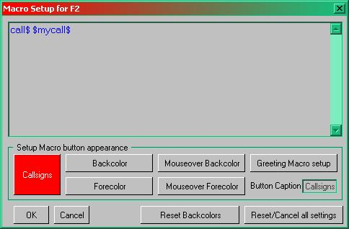

CWM_11

### 5.4 Standard Hot Key Assignments

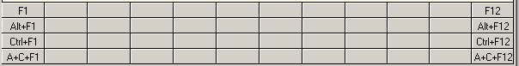

CWM_12

The buttons have default Hot Keys assigned to them. If all 48 buttons are displayed, the first row of 12 buttons corresponds to the F-keys, F1 through F12.  The second row of buttons corresponds to the <**Alt+Fn**> keys (hold down Alt and press the function key).  The third row of buttons corresponds to the < **Ctrl-Fn**> keys. The fourth row of buttons corresponds to the < Alt-Ctrl-Fn> keys. If you press these keys, the script from the corresponding button will run. You can also see these assignments at the top of the Macro Setup window for each key.

### 5.5 User Assigned Hot Keys

If you wish to use other keys, rather than the combination of Function Keys assigned to the buttons, then consider the use of the User Defined Hot Keys. It may be easier to remember that the simultaneous combination of <**Alt+C**> (rather than F1) is the routine for calling CQ.  To assign <**Alt+C**> to the routine for calling CQ, follow this sequence:

* + Using the mouse, right-click on the button you wish to program and the MACRO Setup window will appear;
  + Program the button with text and/or macro commands;
  + Enter a name for the Button Caption (lower right of the window) beginning with the "&" (ampersand) symbol. Example: &CQ; and,
  + Select the <**OK**> button.  Selecting the <**Cancel**> button will cause the window to close without saving your work.

Now when you press the Alt and C keys simultaneously, your CQ will be sent. The label on the button looks like CQ, with the underlined first letter meaning it is a hot key <**Alt+C**>.  Now you can send CQ by three methods:

* 1. Select the button CQ;
  2. Press the F1 key; or,
  3. Simultaneously press the Alt and C keys.

### 5.6 CW Machine Macro Commands

The following Macros are available for use within a button script: See 5.7 Example Scripts Using Macros for some useful examples.

|  |
| --- |
| **Macro** |
| $band$ |
| $bookmark$ |
| $call$ |
| $callchanged$ |
| $callsignbeforeclearlog$ |
| $CallsignGetsFocus$ |
| $clear$ |
| $clearlog$ |
| $command$ |
| $cwspeedup$ |
| $cwspeeddn$ |
| $CWTextGetsFocus$ |
| $greeting$ |
| $hexcommand$ |
| $log$  also see Note 2 below |
| $logimmediate$ |
| $lookup$ |
| $loop$ |
| $loop x$ |
| [$msg(x)$](#$msg(x)$) |
| $mouseTF-Set$  also see Note 7 below |
| $mycall$ |
| $name$  also see Note 5 below |
| $NameGetsFocus$ |
| $receive$  also see Note 6 below |
| $receivedrst$ |
| $reset$ |
| $rotor$ |
| $rotorlp$ |
| $sentrst$ |
| $sentrstn$ |
| $serialnum$ |
| $serialnum-1$ |
| $speed+$  also see Note 3 below |
| $speed-$  also see Note 3 below |
| $SRXGetsFocus$ |
| $TF-Set$ |
| $toggleradios$ |
| $transmit$  also see Note 6 below |
| $tune$ |
| $winkeymergedletters$ |
| ^ character |
| | character  See Note 4 below |

**Note 1**:  Macro commands are only available via the buttons. You cannot type them in the TX window and expect them to work.

**Note 2**: These will work correctly when using the software keyer.

**Note 3**: These will work correctly when using the software keyer and WinKey/WinKey2.

**Note 4**: A "|" embedded in a software CW macro (example: SP2|EWQ) will cause the inter-element spacing between the letters (in the example - between the 2 and the E) to be increased by 50%.

**Note** 5: The $name$ macro may send many things other than just the name, depending on the use of the [CW Free Field](#5.15_Free Field). If there is no NAME, then the $name$ and the trailing SPACE is replaced with nothing. This prevents an extra space being transmitted.

**Note** 6: Can be used when MOX and/or slow typing modes are in use. $receive$ is not an immediate Macro, it switches PTT off when the buffer is empty. $transmit$ is an immediate Macro and switches PTT on only if there are characters in the buffer.

**Note** 7: TAP/HOLD function key for this macro works correctly only when focus is in CW Machine.

### 5.7 Example Scripts Using Macros

This Macro will 'log' the QSO, clear the Logbook Entry window and revert the system back to receive mode.

73 $name$ TNX for the nice PSK QSO.

Hope to catch you on the 'waterfall' again soon...

$call$ de $mycall$ SK SK

$log$

$receive$

This Macro sends the DX station's callsign followed by a word space at the keyer speed. It will then send 5NN at keyer speed + 6 WPM. On completion of the transmission, the keyer speed is reset.

$call$ $speed+$$speed+$$speed+$5NN

**Note**: It is not necessary to have corresponding $speed-$ macros unless you wish to reset the keyer speed within a single transmission.  As in $call$ $speed+$$speed+$$speed+$5NN$speed-$$speed-$$speed-$ QSL?

This will send the DX station's call followed by a word space at keyer speed. It will then send 5NN at keyer speed + 6 WPM.  A word space and QSL? is then sent at normal keying speed.

$call$ de $mycall$ tks fer the qso $name$. 73 es gd dx   $call$ de $mycall$  A^R S^K $log$

 This Macro will send both callsigns, send GM/GA/GE (the greeting) and then the name of the QSO partner.

          $call$ de $mycall$ $greeting$ $name$ nice to hear you again

If you are an inexperienced user of an automatic key, you might prefer to simulate others which seem to send numerals as 6 elements by using the ^ Macro such as:

For 599 enter "E^5T^9T^9" J

### 5.8 The $loop$ Macro

As mentioned above, the $loop$ Macro will introduce a 5 second delay before the Macro in which it is placed starts again. If a longer delay is required, insert more $loop$ commands.  For example the script CQ CQ de $mycall$ $mycall$ $loop$ $loop$ will send CQ CQ your call your call and then wait for 10 seconds before starting again.

After the first sending of the script, the text window will change its background color to the default color of red (configurable from the View | Appearance menu) and it will stay red until the loop script is stopped, whereupon the text background color will revert to its original setting.

You can break the loop by mouse-clicking on any entry field, typing any character, or clicking any shortcut button.

### 5.9 Prosigns (Software Keyer only)

As well as correctly sending the punctuation marks quote ("), colon (:), comma (,), slash (/), question mark (?) and the open and close brackets (( )), the CW Machine also has some pre-programmed keyboard prosigns built in as follows:

**=** sends "BT"

**+** sends "AR"

**&**  sends "AS"

**!**  sends " SN"

**@**  sends "AC"

**-**  sends "DU"

**\***  sends "RR"

### 5.10 Prosigns (WinKey)

WinKey has its own set of prosigns as shown in the following table. Any additional prosigns can be easily generated using the merge character command. (see WinKey documentation)

**"** Sends RR **+** Sends AR

**#** Sends EE (null) **-** Sends DU

**$** Sends SX **/** Sends DN

**%** Sends EE (null) **:** Sends KN

**&** Sends EE (null) **;** Sends AA

**'** Sends WG **<** Sends AR

**(** Sends KN **=** Sends BT

**)** Sends KK **>** Sends SK

**\*** Sends EE (null) **@** Sends AC

### 5.11 Regional Characters (Software Keyer only)

If the language ID of your PC is set to Danish, Finnish, Icelandic, Norwegian(Bokmal), Norwegian(Nynorsk), Swedish, Swedish(Finland) - a language ID of 1030, 1035, 1039, 1044, 2068, 1053 or 2077 the following keyboard characters are supported:

ASCII 197 - Keyboard character (An A with a ring over it) sends ".--.-"

ASCII 196 - Keyboard character (An A with two dots over it) sends ".-.-"

ASCII 214 - Keyboard character (An O with two dots over it) sends "---."

ASCII 198 - Keyboard character (Looks like an A+E) sends ".-.-"

ASCII 216 - Keyboard character (Looks like a zero with a slash) sends "---."

ASCII 222 ? Keyboard character (looks like a pregnant I) sends ".--.."

### 5.12 Other Keyboard Keys

<**PgUp**> and <**PgDn**> have been assigned for keying speed up and speed down.

<**Left Arrow**> and <**Right Arrow**> keys shift the focus between the text pane and the callsign pane.

The <**Up**>/<**Down**> arrow keys will switch the focus between the callsign field and the text entry field.

All Logbook Entry window shortcuts are now active from the CW Machine.

Navigation between Callsign field, STX and Name field is by the <**Tab**> key

### 5.13 CW Callsign Field

If you ever wondered how the QRQ stations can come back with the station's callsign instantly after the other station quits calling, it's because they do this:

Type in G3N, hit transmit to send a Macro with "$call$ 599", and continue typing PA .. What is transmitted from the $call$ Macro is G3NPA (if one types fast enough).

Now, because the CW Machine grabs all the CPU time, this won't work when typing in the call in Logbook Entry window (the messages don't get to the CW Machine in time).

To cut this very long story short, a small window is now provided in the top right corner of the CW Machine. This is a duplicate of the callsign field in Logger32. Try this scenario:

Type in G3N, hit transmit, and continue typing PA to give the continuous callsign of G3NPA.

A callsign can of course be entered into the Logbook Entry window in the normal way, if desired, and it will transfer to this pane.

### 5.14 Previous Calls

Alongside the callsign entry pane, there is a "previous calls" pane. This is automatically populated once a QSO is logged from the CW Machine. Use the small down arrow to see more previously worked callsigns.

**Note**:  The terms "previously worked" or "previous calls" used above refer ONLY to those calls logged during the current CW session

### 5.15 Free Field

By default this pane is set to expect the QSO partner's name.

If you have worked the station before AND you have the QSO mask set to pull out the previously recorded name, then this field will populate automatically.

However, this is actually a free field and it can be set to accept any of the available ADIF fields provided that the field in question is set up to display in one of the user fields in the Logbook Entry window and is shown in the pull-down ADIF list.. For example one might want to be able to collect the IOTA Ref Number given in a contest.

To do this, select the setup user field edit window for the IOTA pane in the log input window and select "Use this ADIF field" in the CW Machine free field section in the lower half of the window.

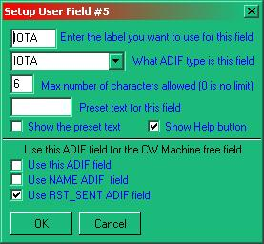

CWM_19

There is one exception to the above and that is the RST Sent field. If this field is required to be collected from the CW Machine, then check the appropriate check box as shown in the above example. The user may select this option using any user field setup.

With this new option (if RST_SENT is selected as the CW free field), RST_SENT can be sent by using the $sentrst$ or $name$ Macros.

### 5.16 SRX Entry Pane

A contest serial number received can be entered here.

By popular demand (and in violation of the ADIF spec), the CW Machine SRX field has been modified to allow entry of non-numeric characters. For contests that exchange other than a simple numeric serial number. If you do enter non-numeric data into this field, don't be surprised if some logbooks reject these QSOs.

## 6.0 INTERFACING THE CW MACHINE

### 6.1 Software Keyer

You cannot key your radio directly from either the serial or parallel ports from your computer and you will need to construct a simple interface depending on which options you select. A typical interface needed for each control wire is shown below, and this in conjunction with the table of connections should be sufficient to get you operational. This interface assumes that your rig gives a positive voltage onto the control and that this needs to be pulled to zero volts to operate.

**Typical interface circuit**

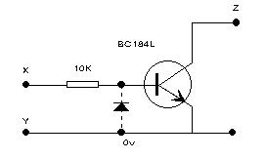

CWM_13

**Notes** on the interface:

* 1. If you are interfacing between a Serial (COM) port and your rig, then include the diode;
  2. If you are interfacing between a Parallel (LPT) port and your rig, then the diode may be omitted;
  3. While a BC184L transistor is specified in the drawing, almost any NPN switching transistor will suffice; and,
  4. The connections to points X, Y and Z in the above diagram should be made in accordance with the following table:

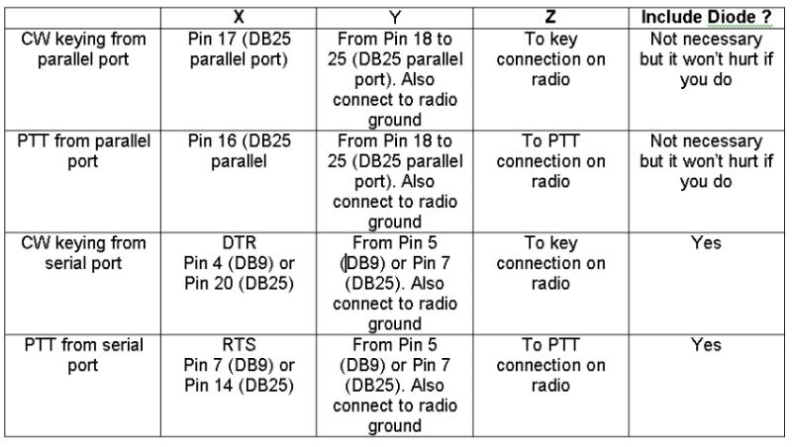

CWM_14

**Note**: If your radio is turned on while Windows is booting up, you may experience a condition where the radio keys up when in the CW mode. To prevent this occurrence, you can use the "STROBE" line (pin#1) as a ground return to the keying circuit. This pin is normally set high when Windows boots up. When you open Logger32 it will set this pin to a low state making it available for CW keying ground return. Additional CW keying information is in the Tips, Tricks and Troubleshooting section.

### 6.2 Alternate Interface

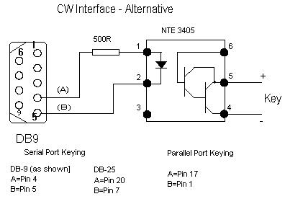

CWM_15

### 6.3 WinKey

Consult your WinKey Interface manual.